FMI, email pennypickel@me.com

NOVEMBER 2025

Monday, November 10. Norfolk Visual Arts at Titustown Sumi-e Open Studio: Signups begin. Session begins 1/07/26 and ends 2/25/26. 2 Sections, 1:30-4:30 p.m. or 4:30-7:30 p.m. Norfolk Visual Arts

Tuesdays, November 4 – December 2. 11:00 a.m. – 1:00 p.m. Sumi-e Japanese Ink Painting, 5-Week Class with Artist Norene Spencer. Register by phone, 757-441-5830, Ext 338, or online at www.Norfolkbotanicalgarden.org Members: $85.00/ Nonmembers $110.00. Sold Out

Saturday, November 15. 10:00 a.m. – 1:30 p.m. Blue Heron Invitation to Paint. Algonquin House. 7320 Glenroie Ave., Norfolk. Bring a dish to share. Contact host: Heidi Schwartz. RSVP not required.

Saturday, November 15. 2:00 p.m. – 4:00 p.m. Internal Workshop: Perspective with MinhChau Truong. Algonquin House. 7320 Glenroie Ave., Norfolk. For details, contact Cathy Peyton. Registration has closed.

Sunday, November 16. 2:00 p.m. – 4:00 p.m. Blue Heron Monthly Meeting. MinhChau Truong will use the new Sumikundo paints for a demonstration of a landscape with mountains, garden path, and road. Kempsville Christian Church, 5424 Parliament Drive, Virginia Beach. To see these watercolor paints, google “sumikundo.” It is available from various sellers online

DECEMBER 2025

Sunday, December 21. 2:00 p.m. – 4:00 p.m. Blue Heron Monthly Meeting. Holiday Card Exchange and Pot Luck. Guests: Kathryn Bush with Holiday Bells and Joe Nicholas with Holiday Magic. Kempsville Christian Church, 5424 Parliament Drive, Virginia Beach.

JANUARY 2026

Sunday, January 18, 2026 2:00 p.m. – 4:00 p.m. Blue Heron Monthly Meeting. Norene Spencer, Kirigami Japanese art of folding paper.

Tuesday, January 6. 11:30 a.m. – 1:30 p.m. Book Club discussion of Portrait of a Thief by Grace D. Li at Vino Italian Bistro, 5200 Fairfield Shopping Center, Virginia Beach. RSVP to Penny Pickel.

FEBRUARY 2026

Sunday, February 15, 2026 2:00 p.m. – 4:00 p.m. Blue Heron Monthly Meeting. Mary Curro and Flo Wolin, Sketching from the Inner Mind.

MARCH 2026

Sunday, March 15, 2026 2:00 p.m. – 4:00 p.m. Blue Heron Monthly Meeting. Marsha Rode, Painting demo to be announced.

APRIL 2026

Sunda, April 19, 2026 2:00 p.m. – 4:00 p.m. Blue Heron Monthly Meeting. Demo by Li-Wen "Amy" Quach following External Workshop.

MAY 2026

Sunday, May 17, 2026 2:00 p.m. – 4:00 p.m. Blue Heron Monthly Meeting. Pot Luck and Blue Heron Calendar Submission.

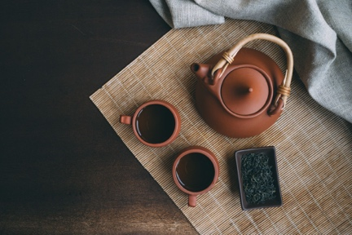
Mark your calendar for our External Workshop in the Spring.
APRIL 18, 19, 2026. Instructor: Li-Wen Quach. Details coming.

